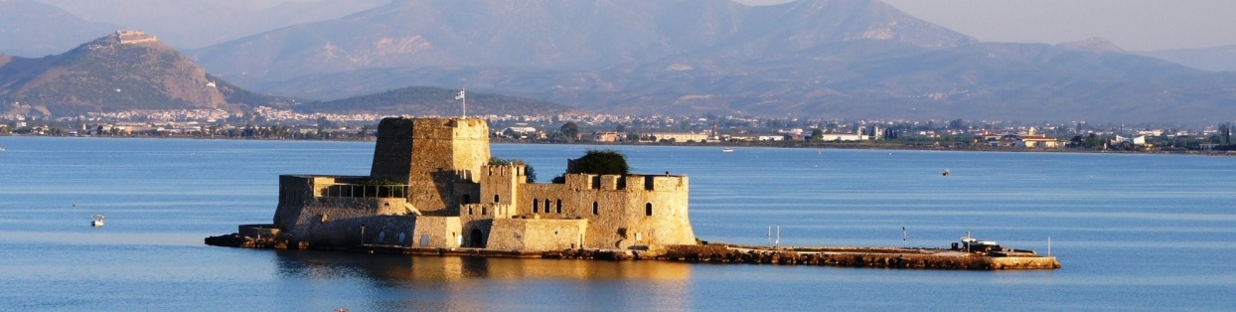

International Conference

Human Dignity in periods of conflicts and crises.
Human Rights and Humanitarian Law at crossroads

26 & 27 May 2017

Venue: Vouleftikon, Νafplion
Opening Time: 16:30

Under the auspices of Mr. Thorbjørn Jagland,
Secretary General of the Council of Europe

Program

26 May, «Vouleftikon», Nafplion

16:00 Arrival of participants, Registration

16:30 Opening of the Conference

Chair: Ambassador Prof. Stelios Perrakis, Permanent Representative of Greece to the Council of Europe

-Message of H.E. the Prime Minister of the Hellenic Republic Mr.Alexis Tsipras
- Maria Giannakaki, Secretary General for Human Rights and Transparency, Ministry of Justice
- Petros Tatoulis, Regional Governor of Peloponnese
- Philippe Boillat, , Director General, Directorate General Human rights and Rule of Law, Council of Europe
- Demetrios Kostouros, Mayor of Nafplion
- Prof. G. Tsaltas, President of the Hellenic Society of International law and International Relations

17:15 Introductory addresses: Human Dignity in times of Conflicts and Crises

Philippe Boillat, Director General, Council of Europe
Dominik Stillhart, Director of Operations, International Committee of the Red Cross

17:45 Keynote speech

Guido Raimondi, President of the European Court of Human Rights

18:20 – 19:30 High level Round Table: Human Dignity in times of crises

Chair: Prof. J-P Jacqué

- Prof. Georgios Katrougkalos, Alternate Minister of Foreign Affairs
- Stavros Lambrinidis, EU Special Representative for Human Rights
- Gudrun Mosler-Törnström, President of the Congress of Local and Regional Authorities, Council of Europe
- Prof. Veronika Bílková, Member, Venice Commission
- Prof. Petros Pararas
- Prof. Antonis Bredimas

19:40 «A.Polyzoidis-G.Tertsetis» Justice and Law Award Ceremony, by the Municipality of Nafplion, to honor the President of the European Court of Human Rights Mr. Guido Raimondi, and the President of the Administrative Tribunal of the Council of Europe and Former Vice-President of the European Court of Human Rights, Mr. Christos Rozakis, for their contribution in International Justice and the promotion of Human Rights Law.

-Vin d’honneur

27 May

09:15-11:10 1st Round table: Human Rights and International Humanitarian Law at crossroads

Chair: Prof. Christos Rozakis, President of the Administrative Tribunal, Council of Europe

- Prof. Stelios Perrakis: Humanitarian law and Human Rights Law: from fragmentation to complementarity
- Dr.Knut Dörmann: ICRC and International Humanitarian Law challenges
- Prof. Kostas Chatzikonstantinou: Human Dignity in the Case-law of the European and International Courts
- Christos Giakoumopoulos, Director of Human Rights, Human Rights Directorate, CoE
Extra-judicial killings, Detention, ill treatment
- Achilleas Demetriades, Lawyer: Missing persons, Human Rights, Justice and Truth

Discussion

11:25-13:30 2nd Round Table: Methodology of monitoring and fact finding in armed conflicts and crises situations

Chair: Judge Linos-Alexandre Sicilianos, Vice-President, European Court of Human Rights

- Prof. Thilo Marauhn, President, International Humanitarian Fact-Finding Commission: Fact-finding missions in armed conflicts and crises situations: Lessons learnt and the role of the international Humanitarian Fact-finding Commission
- Katarzyna Gardapkhadze. First Deputy Director of ODIHR, OSCE (tbc)
- Anne Brasseur, Member, PACE (Former President): Parliamentary Diplomacy in conflict situations
- Costas Paraskeva, Committee for the Prevention of Torture (CPT): Monitoring places of detention in conflict situations
- Assist. Prof. Daniella Marouda, Member, ECRI, Council of Europe: State consent to and flexibility of monitoring operations : taking stock of State and international organizations’ practice
- Jean-Philippe Bozouls, Director, Congress of Local and Regional Authorities: Monitoring as a crisis prevention - International monitoring of local and regional autonomy issues

13:30-15:20 Pause/Break

15:30- 17:30 3rd Round Table: Reception and accommodation challenges in case of large scale population movements

Chair: Prof. Haritini Dipla, University of Athens

- Ioannis Mouzalas, Minister for Migration: Europe, Greece and the refugee crisis: An ongoing challenge
- Kalliopi Stefanaki, Head of Refugee Protection Section, UNHCR, Greece
- Prof. Dimitris Christopoulos, President, FIDH : State and non-state actors’ experiences from the recent refugee crises
- Amb. Tomas Bocek, Special Representative on Migration and Refugees, Council of Europe: Children at risk
- Prof. Neophytos Loizides, Council of Europe expert: A Comprehensive Framework for Durable Returns
- Lora Pappa, President,NGO “METAdrasi”, The Greek and European challenge: The situation of unaccompanied minors in Greece
- Sari Nissi, Head of Mission, ICRC Athens: The restoration of dignity of the missing and the dead.
- Nawel Rafik-Elmrini, Councilor,Deputy Mayor for European and International Affairs, Municipality of Strasbourg, & Eleni Tsetsekou, DGI, Head of SOGI Unit, Council of Europe: Living conditions of vulnerable groups in crises situations

17:30- 17:45 Break

17:45- 19:30 Final Round table:
Human Dignity as a global value for Europe: a trans-disciplinary approach
In partnership with les Rencontres Interdisciplinaires Franco-Helléniques

Chair: Prof. Florence Benoît-Rohmer

Panelists:
Prof. Y.Metaxas
Prof. J-P Jacqué
Prof. Y. Panousis
Prof. K.Chrysogonos
Assist. Prof. D. Akrivoulis,

19:30 End of the Conference

20:00 Palamidi Fortress

Songs...on the hill, Τhe Women vocal Ensemble « Symphonia» of Nafplion,
«Agios Andreas» Bastion.

Reception at the ‘Balcony’ of Palamidi, offered by the Mayor of Nafplion.

